**IBM API Connect Operator Installation**

1. Login to the OpenShift Console with the provided URL. Once logged in click **OperatorHub** under **Operators** menu.

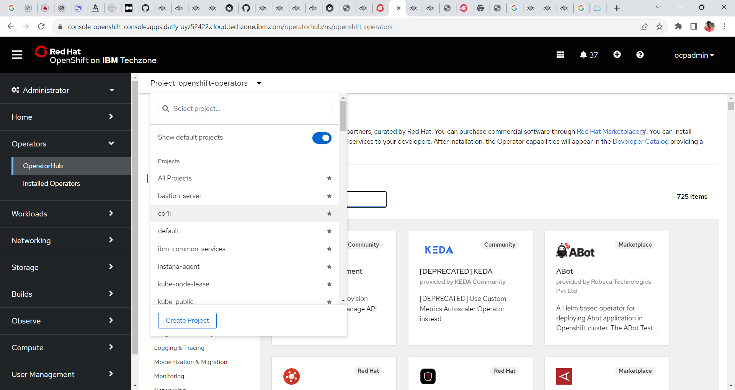

2. In the operator hub search for the tile **IBM API Connect** and click on it.

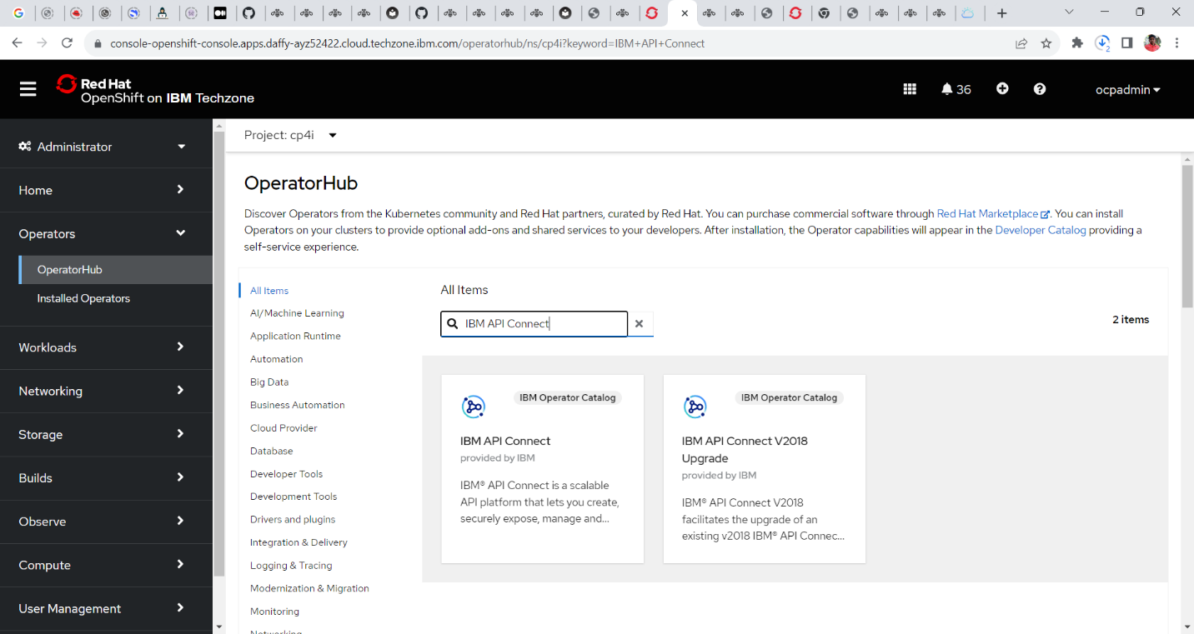

4. Read the document in the window and click on the **install** button.

5. In next window select the following configurations

**update channel = 3.7**

**installation mode = All Namespace on the Cluster**

**Installed Namespace = openshift-operators**

**Update Approval= Automatic**

And Click **Install.**

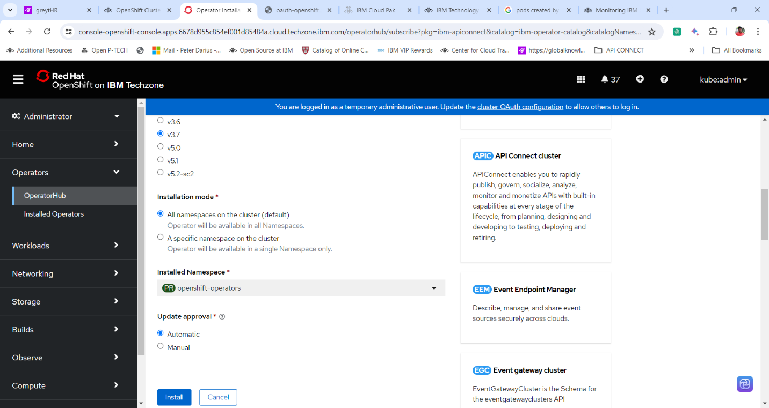

6. The Openshift Container Platform starts to install the operator. Wait for a few minutes until the completion of the installation.

7. Once the IBM API Connector operator is installed and ready to use click **view operator** to view the details of the IBM MQ Operator.

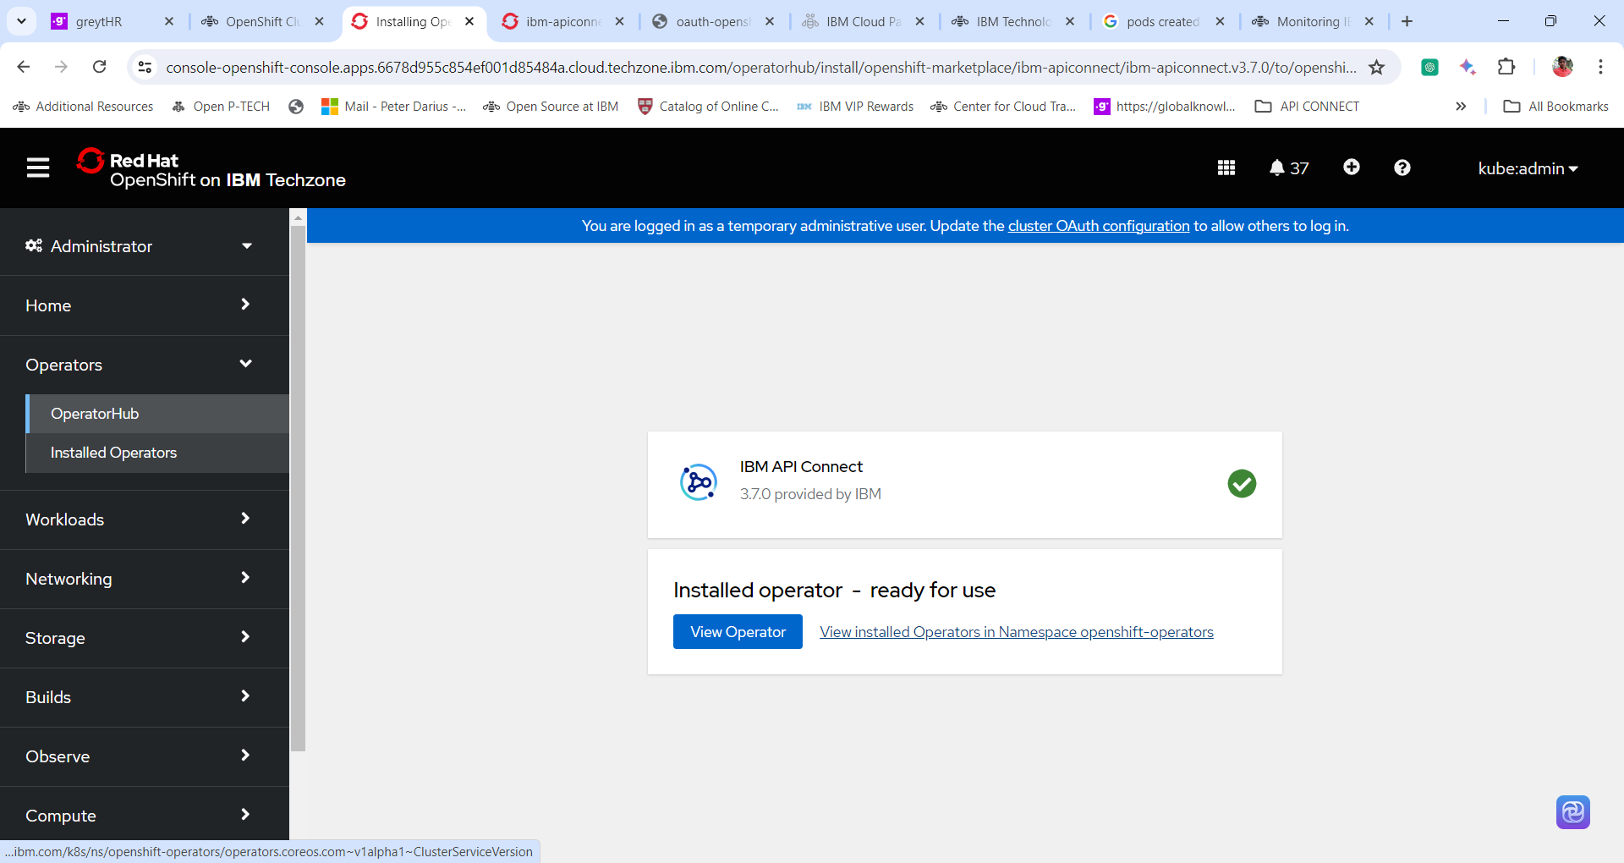

8. Go through the Details of the operator.

**Thanks for completing the Lab**